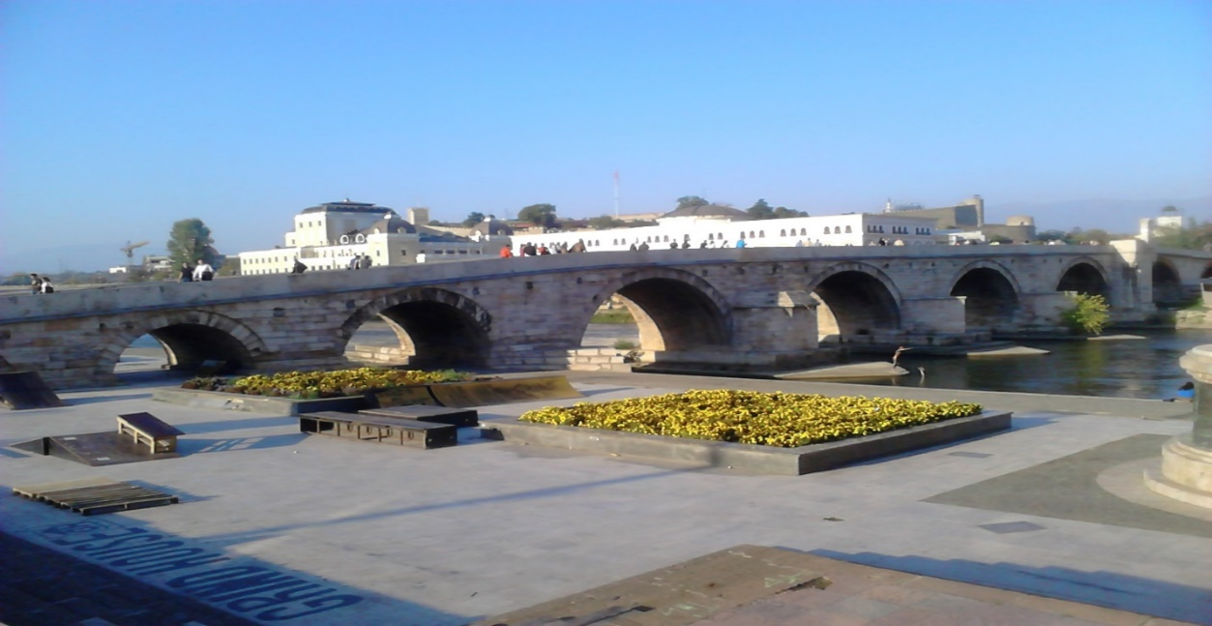

7th MSNDTAO Congress
Macedonian Society of Nephrology,
Dialysis and Artificial Organs
with International participation
and
ISN supported CME course with ERA endorsement
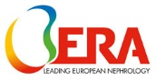
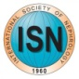
“From Prevention to Best Treatment Options in CKD”
&
IPNA teaching course
“Rare Diseases in Pediatric Nephrology”
04-07 April 2024

Skopje, N. Macedonia
Venue: Holiday Inn hotel Skopje
https://mzndtvo.com.mk
WELCOMING ADDRESS OF THE PRESIDENT

As President of the Congress and on behalf of the International and Local Organizing Committee it is my great privilege to welcome you to the 7th Congress of the Macedonian Society of Nephrology, Dialysis, Transplantation and Artificial Organs (MSNDTAO) with International Participation and International Pediatric Nephrology Association (IPNA) Teaching Course “Rare Diseases in Pediatric Nephrology” to be held in Skopje, N. Macedonia, 04-07 April, 2024.
The Congress is supported by the International Society of Nephrology (ISN) and the ISN Course “From Prevention to Best Treatment Options in CKD” will follow at the last days of this extraordinary event. The event is also ERA endorsed. This Congress is certainly a special occasion for those who work for the development of Nephrology, in education, research and professional development. It will be an occasion to meet, to listen, to discuss, to share information and to plan for the future. Also, the IPNA teaching course will take place alongside these events, emphasizing the challenges that our youngest patients are facing and present the new treatment options for this most vulnerable population.
The Scientific Committee of the Congress has paid great attention to various topics in the field of Nephrology and the treatment of chronic renal disease. The invited speakers, all well-known distinguished international experts and scientists, are coming from different parts of the Balkans and the world. During the Congress, issues will be discussed through a state-of-the-art presentations and mini lectures involving Clinical Nephrology, Hypertension, Nephrolithiasis, Urinary tract infections, Adult dominant polycystic kidney disease, Prevention and treatment of Chronic Kidney Disease, Renal Replacement Therapy (Hemodialysis, Peritoneal Dialysis, Kidney Transplantation). In depths exchange of the knowledge within dedicated sessions will be at the chapters on Vascular Accesses (creation, surveillance and management of complications, both medical and surgical), Immunosuppressive treatment in Clinical nephrology and Kidney transplantation, etc.
I am deeply convinced that this event will be of an exceptional importance for the region, considering that we will be able to see all the international achievements and the most up-to-date methods used in the Nephrology field. I certainly hope that this rich variety of speakers and activities will provide fresh impetus for advancements in education as well. I am confident, too, that we'll further proceed with our well established regional friendly spirit or even get stronger bonds among us all, nephrologists who share the common goal of improvement in the Nephrology sphere.
Thus, we'll be able to propose to our health decision-makers introduction of proven state of the art procedures in the prevention and treatment of kidney disease, which will improve the quality of life of our patients.
We have tried to provide learning opportunities from experts, but also, we invited many colleagues from the region to actively participate sharing their clinical experience and research.
We are exceedingly counting on your active involvement to foster and exalt the clarification of the chosen scientific topics.
The host city Skopje will introduce its rich cultural places, historic tradition, mixture of old and modern architecture. It is the capital and largest city in the Republic of North Macedonia, with more than a quarter of the population of the country, as well as the political, cultural, economic and academic centre of the country. We would encourage you to take a walk along our river “Vardar”, stroll along the narrow streets of the Old Bazaar, which is the biggest bazaar preserved in the Balkans today, Kale fortress, and certainly visit St. Pantelejmon church and admire the fresco ”Lamentation of Christ”, bearing the first signs of the Renaissance and the Matka canyon. Great traditional food and unique Macedonian wine, hospitality of the people, beautiful landscapes are the main reasons for each visitor to have unforgettable stay in Skopje.
I hope to see you here in Skopje in April to enjoy the Congress that we hope will be of interest to you and to simultaneously enjoy a pleasant welcoming city full of attractions.
Sincerely,
Prof. Goce Spasovski, President of the Congress

SCIENTIFIC INFORMATION
ORGANISING COMMITTEE

Goce Spasovski
President of the Congress
President of the MSNDTAO

SCIENTIFIC COMMITTEE
Chair
Velibor Tasic

MAIN TOPICS
  - Clinical Nephrology,
  - Hypertension,
  - Nephrolithiasis,
  - Urinary tract infections,
  - Adult dominant polycystic kidney disease,
  - Prevention and treatment of Chronic Kidney Disease,
  - Renal Replacement Therapy (Hemodialysis, Peritoneal Dialysis, Kidney Transplantation)
  - Advanced treatment of CKD progression & Diabetic Kidney Disease
  - Pediatric nephrology

GENERAL INFORMATION

SCIENTIFIC INFORMATION
Official languages are Macedonian and English

CONGRESS VENUE
The Congress Venue will be the Hotel Holiday Inn located into the city centre

SOCIAL PROGRAMME
OPENING CEREMONY
Thursday, 04 April 2024 at 19:00

WELCOME RECEPTION COCKTAIL
Thursday, 04 April 2024 at 20:30

PRESIDENTIAL DINNER
Saturday 06 April 2024 at 20:00
*Additional invitation card for social events can be purchased at registration desk at a price of 25 EUR

LUNCH AND COFFEE
Lunch will be included in the Congress package as walking lunch in front of the halls for lectures and poster session. Coffee and mineral water will be served in front of the respective Congress halls.
WEATHER
The weather in April in Skopje is usually sunny and moderately warm during the day and humid and cool at night. Temperature of the air varies between 16⁰C and 24⁰C

CURRENCY
Macedonian denar: approximately 1 EURO = 61.5 DEN.

BANKS
Banks operate from Monday to Saturday 08:00 - 18:00 hours. (Working hours may vary between different banks).

CREDIT CARDS
International credit cards are accepted in ATM’s, restaurants, shops and agencies.

TIPS
Service is included in the bill in bars, restaurants, etc.

EXHIBITION
A commercial exhibition of the companies operating in the region with their medical products will take place in front of Conference halls from Thursday, April 04th, 15:00, till Sunday, April 07th, 14:00 hours. Access is free to the registered participants.

REGISTRATION OF PARTICIPANTS AND REGISTRATION FEES

REGISTRATION INFORMATION
Participation is open to all health care professionals interested in nephrology, dialysis, transplantation, and artificial organs. To register for the Congress (MSNDTAO meeting), please complete the enclosed Registration Form.
REGISTRATION FEES
Registration/ Регистрација | Before 7th of March, 2024 | After 7th of March, 2024 | Group* before 7th of March, 2024 | Group* after 7th of March, 2024 | Members & young fellows /
 | 140 EUR | 160 EUR | 120 EUR | 140 EUR | 100 EUR

REGISTRATION FEE INCLUDE
Admission to all Meeting Sessions
Congress badge, bag and printed materials
Coffee Breaks and lunch from 04-07 of April
Welcome Reception
Presidential Dinner

Registration is not refundable
*Group is minimum of 10 persons

INSURANCE By registering for the Congress the Organising Committee does not assume any liability. Participants are advised to arrange their other type of insurance.
Registration fees are paid on the bank account of MSNDTAO
EUR – Stopanska Banka AD Skopje
ul. 11 Oktomvri br. 7
SWIFT STOB MK 2X
ID.1067767
IBAN: MK 07200000885886927
МКД – Стопанска банка АД Скопје: 200000013454183
Or to the Congress agency
Travel & Tourist Center – Biser Travel; Bul. Majka Tereza 18, lok. 4, 1000 Skopje, Republic of North Macedonia. Phones: ++389 2 2400 277; Mob: ++389 70 355 074 ; е-mail: jane.janev@bisertravel.com.mk, www.bisertravel.mk

CONGRESS OFFICE
Congress desk will be located in front of the main Congress hall:
Thursday 04 April ………........,...............................................................16.00 – 19.00
Friday 05 April............................................................................................ 8.00 – 19.00
Saturday 06 April....................................................................................... 8.00 – 19.00
Sunday 07 April............................................................................................8.00 – 13.00

HOTEL ACCOMMODATION
- The organizer of the Congress has selected several hotels, which will be available in that period, with preferential prices.
- For accommodation requirements contact the Congress agency: е-mail: jane.janev@bisertravel.com.mk,
ABSTRACTS AND PRESENTATIONS

CALL FOR ABSTRACTS
The Organising Committee invites authors to submit Abstracts for consideration for presentation and inclusion in the programme for the following topics:
Clinical Nephrology, Hypertension, Nephrolithiasis, Urinary tract infections, Adult dominant polycystic kidney disease, Prevention and treatment of Chronic Kidney Disease, Renal Replacement Therapy (Hemodialysis, Peritoneal Dialysis, Kidney Transplantation) and Varia.
SUBMISSION
Abstract must be submitted electronically through the Congress website https://mzndtvo.com.mk or to Goce Spasovski - spasovski.goce@gmail.com (BANTAO and MSNDTAO Congress), no later than February 25th, 2024.
STYLE
Spacing: Abstracts must be typed at 12 points, in Times New Roman, single-spaced in English or Macedonian and should contain no more than 250 words, including the title, authors, institutions and the body of the abstract (Introduction, Methods, Results, Conclusion).
LAYOUT
Title: In capital letters, neither underlined nor bold. Do not identify yourself in the title.
Author(s): Not in capital letters. Write the initials of first names first, and then family names. Only the presenting author must be underlined. The underlined name must be the same as indicated in the address for correspondence.
Affiliation: Not in capital letters. When more than one institution is mentioned, please identify them with superscript numerals and not with symbols (e.g. P. Dow¹, G. Sute², ¹University of Leeds, ²University of Berlin, etc.).
Text: Tables are only accepted without gridlines. Use only well-known abbreviations or explain abbreviations the first time they appear.
Conditions: The material in the Abstract must be original and must not have been published or presented previously at an international meeting.
ACCEPTANCE
Authors will receive a notification of acceptance or rejection for presentation by March 7th, 2024.

CERTIFICATE OF ATTENDANCE
All registered participants will receive Certificate of Congress Attendance, as well as CME credits.
PRESENTATIONS
INVITED LECTURES
The time for each presentation is predefined to 20-25 minutes including 3 min for discussion (if not announced differently). We kindly ask all speakers to stick to the allocated time frame since any extension will not be allowed.
FREE COMMUNICATIONS
All abstracts will be evaluated and the best scored will be nominated for oral presentation. Each presentation will last 8 minutes and will be followed by 2 minutes discussion.
POWER POINT - DATA LCD PROJECTOR:
All presentations need to be prepared as MS Power Point format and all speakers should bring their presentations stored on USB memory stick to be downloaded in each respective hall a couple of hours before their respective session.
POSTER PRESENTATION
The Poster presentations (3 min +2 min discussion) will be shown on a plasma screen during the congress and will be presented by the authors at the poster sessions. All Posters must be prepared as a power point, converted into PDF and sent to us as a PDF File. Each Poster presentation may include up to 7 PowerPoint slides. You are welcome to include images and tables; however videos, animations and transitions cannot be included in the PDF of the Poster. The first page of the presentation must include:
• Abstract title
• Abstract authors (First name, Last name, Affiliation and Country)
The details should be exactly the same as the submitted abstract. Please include author’s contact details within the presentation final slide.
Please load the slides at least 30 min before the session starts.

ALL SPEAKERS and CHAIRS SHOULD RESPECT THE ALLOCATED TIME FRAME

